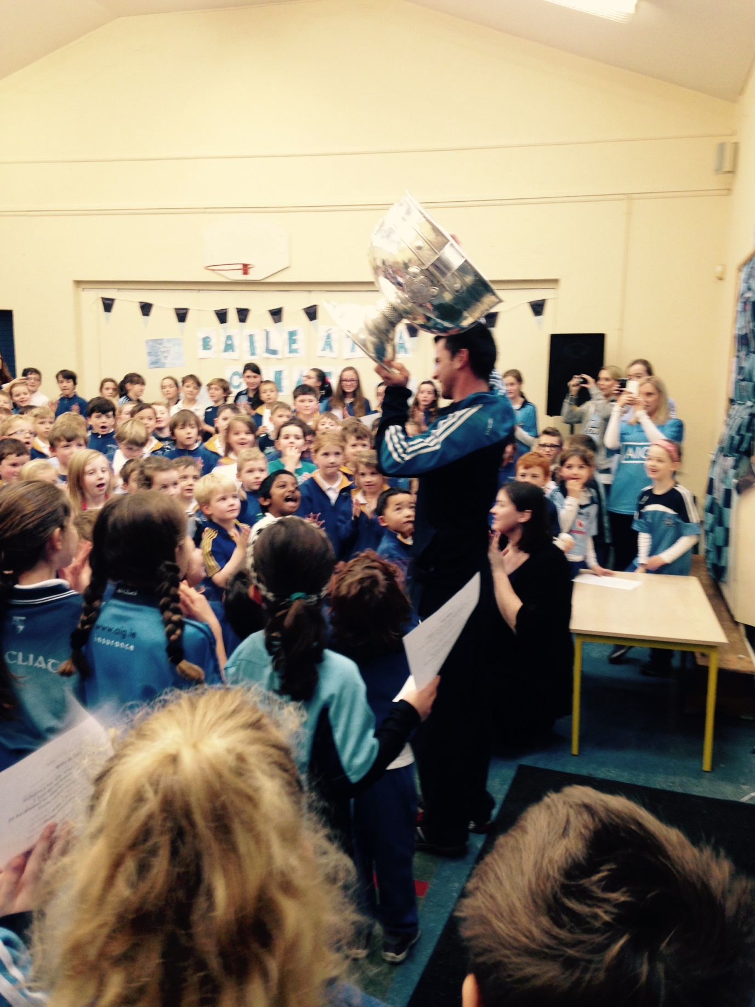 in Sam Maguire was brought to our school after Dublin won the All Ireland Football Final 2015.

